Installation Guidelines for Vision Insight
FOR

BI DASHBOARD WEB APPLICATION
SUBMITTED TO
IVTECH COMPUTER SYSTEMS LLC

Version: 1.0

08th AUGUST 2025

Prepared By:
SPEC INDIA
Revision History

Date | Version | Author | Created / Updated / Reviewed / Verified / Approved By
08-08-2025 | 1.0 | Parth Jotangiya | - Initial Draft
08-08-2025 | 1.0 | Yaman Kavishwar | - Reviewed and approved

Table of Contents
Contents
1. Introduction 4
1.1. Guidelines for Installing the Application on a Fresh Machine: 4
1.2. Software dependencies: 7
1.3. Prerequisite for SSL Configuration: 8
1.4. Reconfigure the SSL certificate: 10

Introduction

- This section provides step-by-step instructions to install the application on a target machine. Before proceeding, ensure that all prerequisite software, hardware configurations, and network settings are in place as per the system requirements.
- The installation process involves downloading the latest installer package, executing the setup file with administrator privileges, and following the on-screen prompts to complete the configuration.
- During installation, it is important to carefully review each step, select the appropriate installation path, and verify that all required components are installed successfully.
- Once completed, perform a quick system check to ensure the application launches without errors and is ready for use

Guidelines for Installing the Application on a Fresh Machine:

- Download the latest installer package from the specified location.
- Run the Vision Insight Installer.exe file as an administrator.
- After this step, the following screen will appear. Select the location where you want to install the application, then click "Next" to continue:
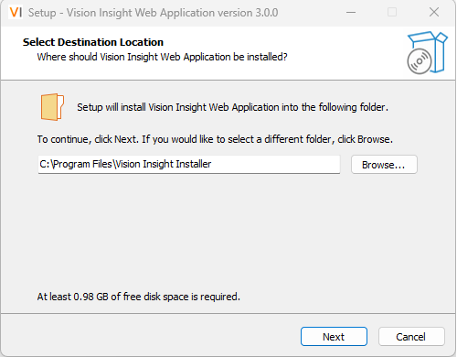
- The next screen will display all the required software dependencies. Click "Next" to continue:
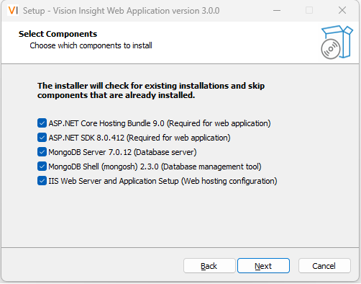
- The next screen will prompt you to specify the name of the program’s shortcut, which will appear in the Start Menu when searching for the application. Click "Next" to continue:
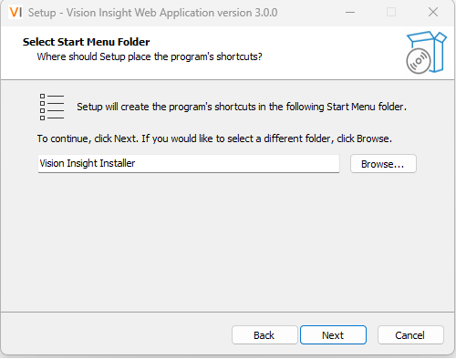
- The next screen will be "Ready to Install". Click the "Install" button to initiate the process. This will install the application along with all necessary components on the local machine:
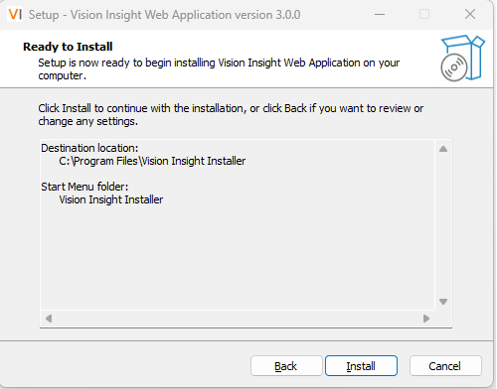
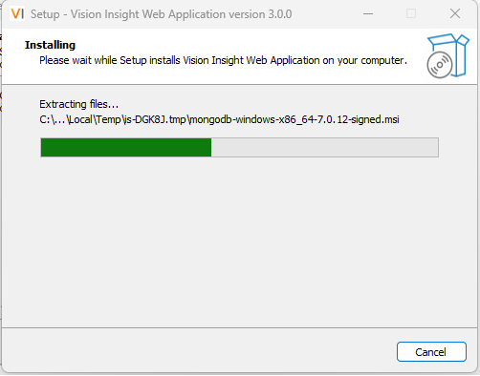
- After the installation is successfully completed, the following screen will appear. Click the "Finish" button to complete the setup. It is recommended to restart your machine after the installation.
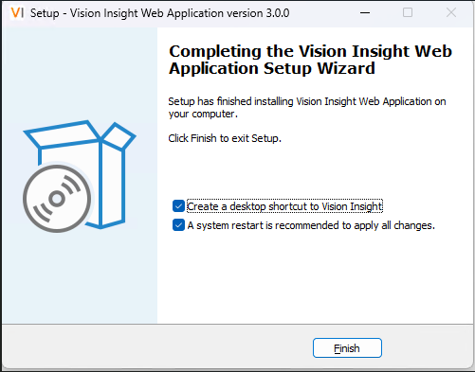
- You can now search for the application in the Start Menu or open it directly using the desktop icon.

- By default, the application will launch using the following URL: http://localhost:8090/.

Important Points:

  - If you are unable to access the application, restart your system once and try again.
  - If the application is not accessible, please verify that the IIS server is enabled, the MyApp website is started, and the MyAppPool status is started.
  - If you have manually uninstalled MongoDB from your system, you must delete the folder C:\Program Files\MongoDB from your file system. Otherwise, MongoDB will not be reinstalled using the Vision Insight Installer, and it may cause issues during the application installation.
  - If you have manually uninstalled the Vision Insight Application from your system, you must delete the folder C:\Program Files\Vision Insight Installer from your file system before reinstalling.

  - If the application still encounters issues, please ensure that all required software dependencies are installed on your machine. The complete list of dependencies is provided in Section 1.2 – Software Dependencies.
  - If any dependency is missing, install it manually. All necessary setup files are available in the /Dependencies directory of the installation package folder.

Software dependencies:

- The following software dependencies must be installed on the local system using the installer only.
- A screenshot is attached for your reference:

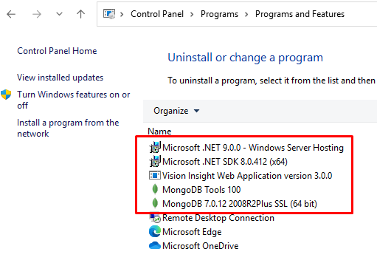

Prerequisite for SSL Configuration:

- To configure SSL and run the Vision Insights Application over the HTTPS protocol, the user must complete the following six steps. After that, upload the certificate file from within the Vision Insights Application.
  - Open IIS and click on Application Pools.
  - From the list, select My App Pool.
  - In the right-hand menu, click Advanced Settings.
  - In the Identity field, click Browse.
  - Under the Application Pool Identity pop-up, select Local System from the drop-down list in the Built-In Account section.
  - Click OK and refresh IIS.
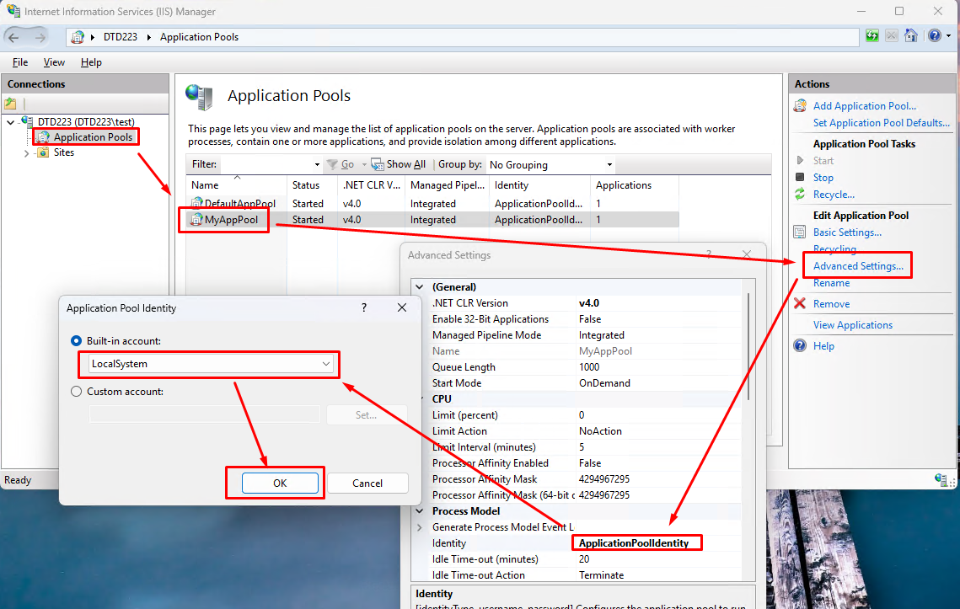

Reconfigure the SSL Certificate:

- If the user wants to upload a new certificate, they must first delete the existing port 443 binding (as highlighted in the image below):
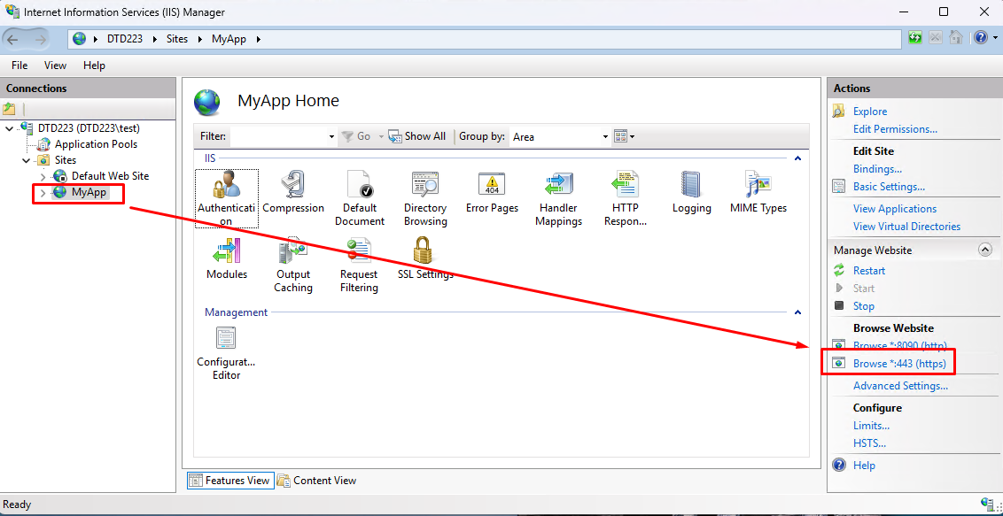

---- end of document ----

